Experiment 5

Write a shell script and c program to perform the following string operations :

1. To extract a substring from a given string.

Shell String:

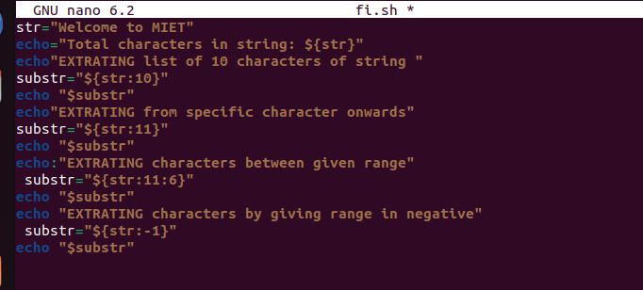

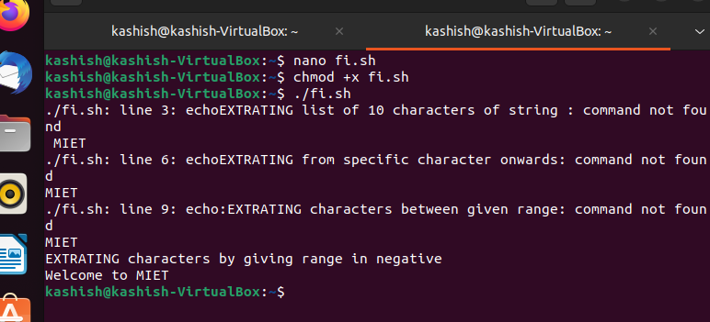

C PROGRAM

